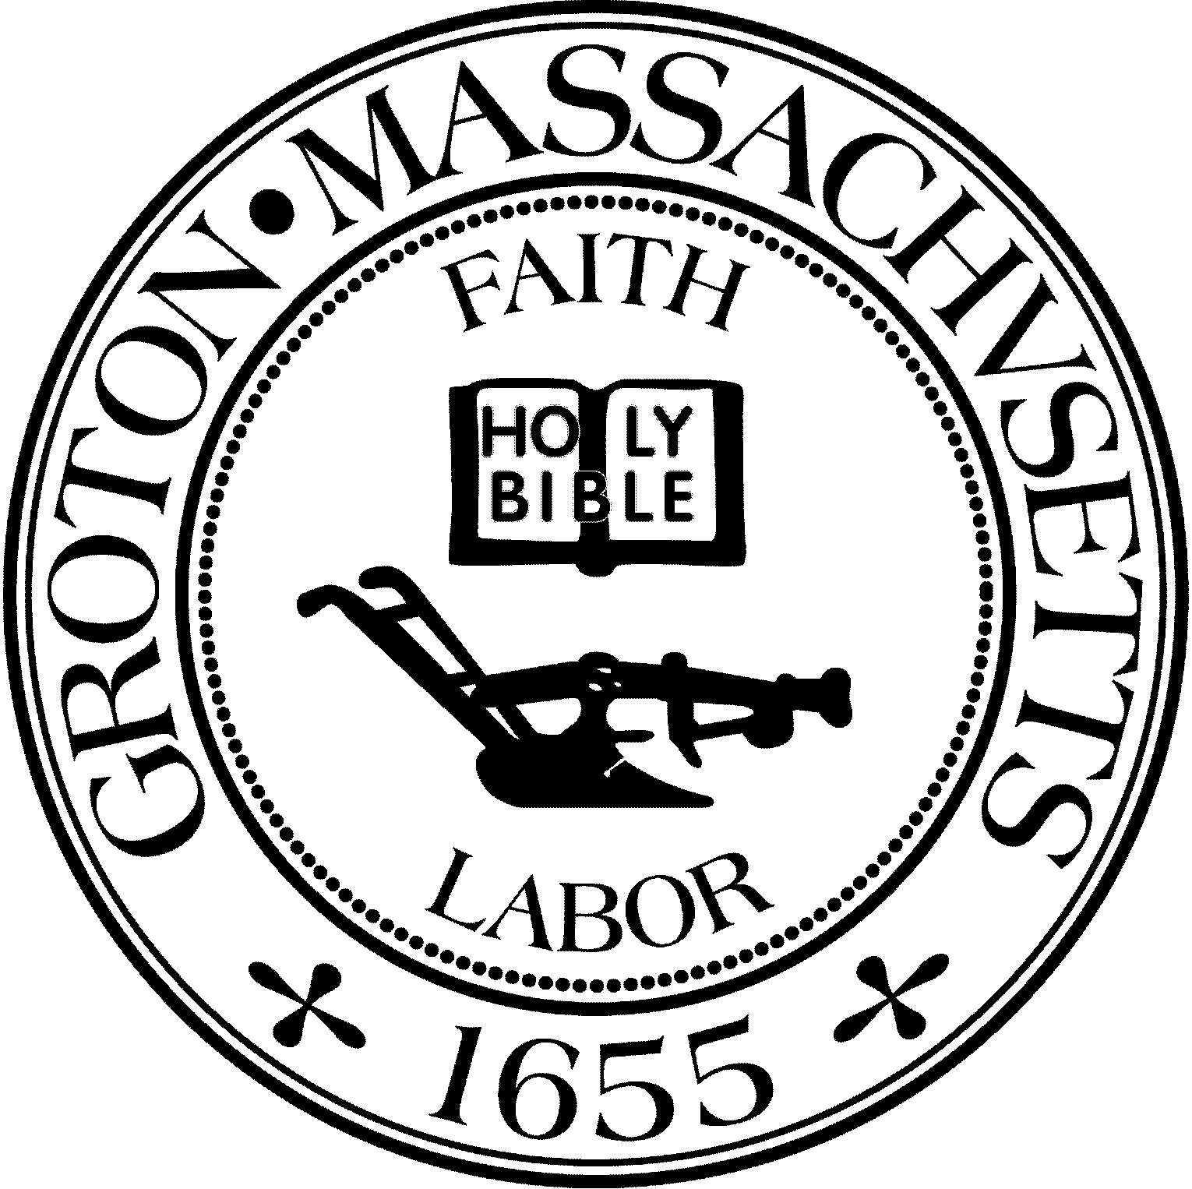

TOWN OF GROTON
173 Main Street
Groton, Massachusetts 01450-1237
Tel: (978) 448-1111
Fax: (978) 448-1115

Destination Groton Committee
Gregory M. Sheldon, Chair
Jeff Gordon, Vice Chair
Julie Platt, Clerk
Joni Parker Roach, Member
Brian Bolton, Member
Town Manager
Mark W. Haddad

January 4, 2024

Mr. Russell Burke, Chair
Community Preservation committee
173 Main Street
Groton, MA 01450
Re: Support for Trials Committee $11,275 grant request

Dear Community Preservation Committee Members:

At our January 3, 2024, the Destination Groton Committee voted unanimously (5-0) to submit this letter of support for the Trails Committees grant request for $11,275.00 before the Community Preservation Commission (CPC).
The funds will purchase special tools and equipment to be used to improve the Trails Committee's overall efficiency and capacity for building, repairing, and enhancing trails in the Groton Trail Network (GTN).
In celebration of the 25th anniversary of the Trails Committee, The Destination Groton Committee assisted in securing a $15,000 State appropriation for improving signage on our Town trails. We are pleased to submit this letter of support to further the mission and success of the Trials Committee into the future.
Sincerely,
Gregory M. Sheldon
Gregory M. Sheldon
Chair

